Troubleshooting Day 2

# Team B

Sachin John Thomas

A.K. Anandan

Alfred Varghese

Ajin Raj

# Shell Scripting

Shell scripting is the process of writing scripts using a shell interpreter like .sh. It allows to automate repetitive tasks, run sequences of commands, and manage system operations.

**Step 1 : Create and Edit the shell file**



**Step 2 : Enter the required script**

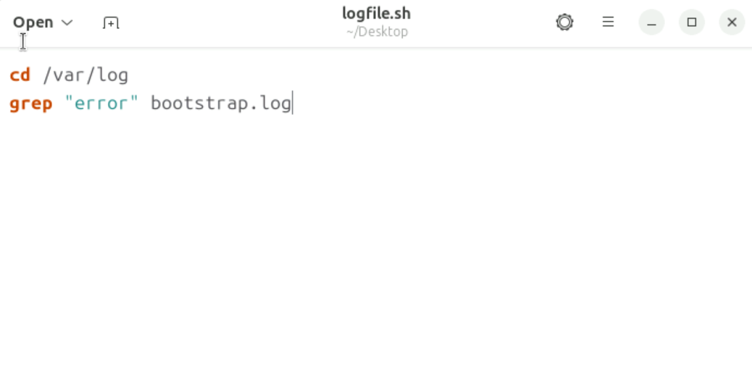

**Step 3 : Execute the file**

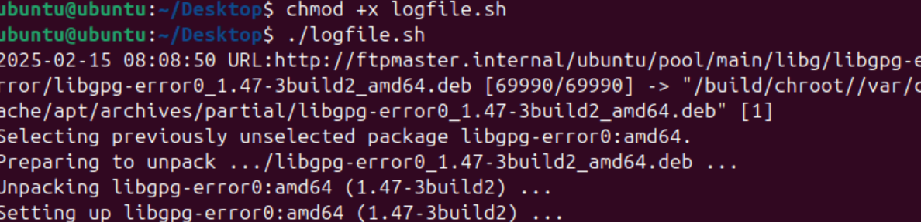

*Note : +x adds the permission to execute the file*

# Important commands Learned Today

1. awk
2. grep
3. tail
4. cut

# awk

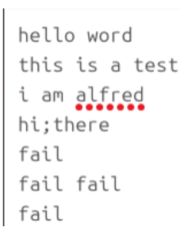

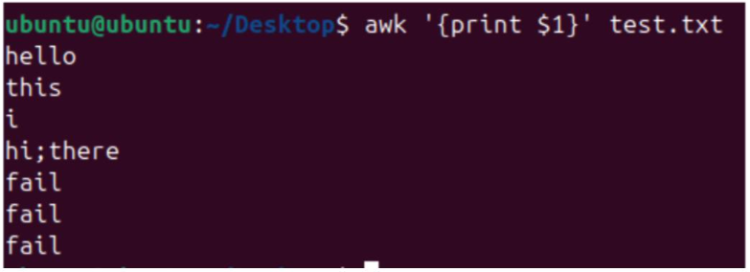

# grep

The grep command in used to search for text patterns within files or output from other commands.

grep “text” insert/your/path/here/path.log is used to find the required text in path.log  
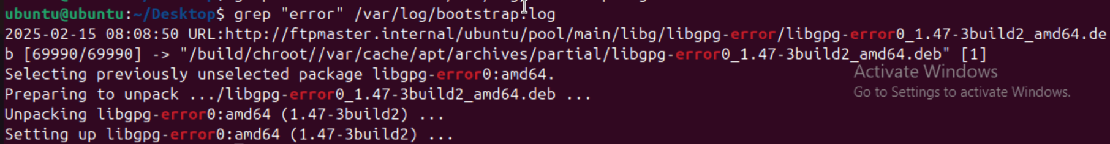

grep -i is used to ignore case sensitivity

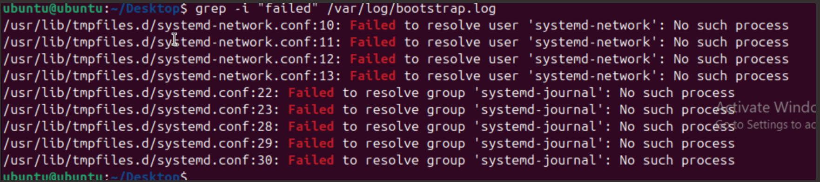

# tail

The tail command in Linux is used to display the **last few lines** of a file.

tail -f is used to monitor files live.

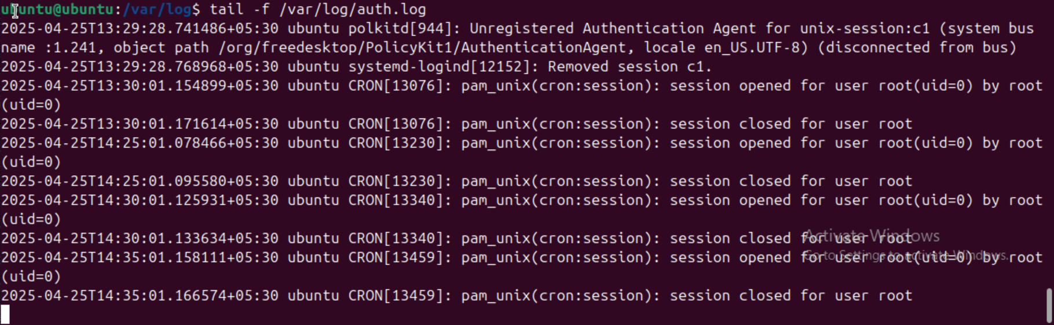

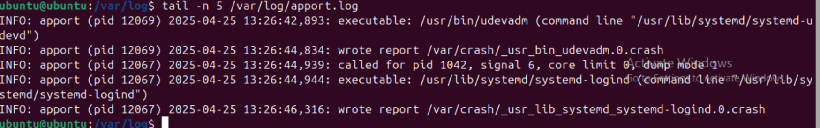

# Troubleshooting



Solution

